**WS25 - EXAM 2 UML Exercise REVIEW**

**Rubric:**

NAME: grade 8/10 -> 12/15

Q38-51

A ->

* + name /0.5
  + attributes /0.2
  + constructor /0.2
  + setters & getters /0.1

B ->

* + name /0.5
  + attribute /0.5

C ->

* + extends /0.5
  + attribute /0.2
  + constructor /0.2
  + setters & getters /0.1

D ->

* + extends /0.4
  + constructor /0.4
  + setters & getters /0.2

E ->

* + name /0.8
  + toString /0.2

F ->

* + name /0.8
  + toString /0.2

G ->

* + implements /0.5
  + method m() /0.5

H ->

* + interface and name /1.0
  + method m /1.0

J ->

* + name /0.8
  + toString /0.2

main ->

* + A a /0.4
  + ArrayList<B> bs /0.4
  + C[ ] cs = new C[3] /0.4
  + D[ ] ds = new D[4] /0.4
  + println() /0.4

**DATE: 18th january2022**

14 CORREA RUIZ KERLY YADIRA: grade 8.40/10 -> 12.6/15

Inspector : Darling Cruz

Q38-51

A ->

* + name 0.5/0.5
  + attributes 0.2/0.2
  + constructor 0.1/0.2
  + setters & getters 0/0.1

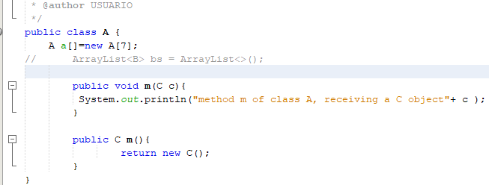

B ->

* + name 0.5/0.5
  + attribute 0/0.5

C ->

* + name 0.5/0.5
  + attributes 0/0.2
  + constructor 0/0.2
  + setters & getters 0/0.1

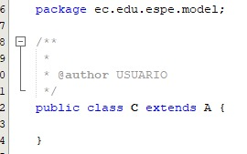

D ->

* + extends 0.4/0.4
  + constructor 0/0.4
  + setters & getters 0.2/0.2

E ->

* + name 0.8/0.8
  + attributes 0/0.2

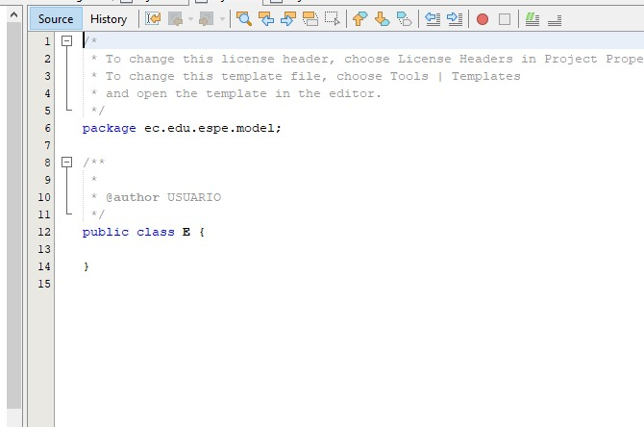

F ->

* + name 0.8 /0.8
  + to String 0 /0.2

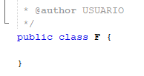

G ->

* + implements 0.5/0.5
  + method m() 0.5/0.5

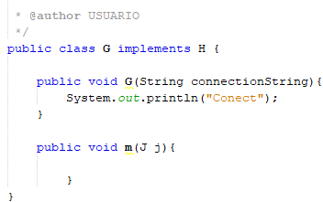

H ->

* + interface and name 1.0/1.0
  + method m 1.0/1.0

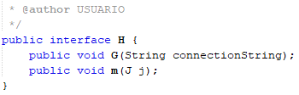

J ->

* + name 0.8/0.8
  + to String 0.2/0.2

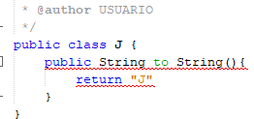

main ->

* + A a 0.4/0.4
  + ArrayList<B> bs 0/0.4
  + C[ ] cs = new C[3] 0/0.4
  + D[ ] ds = new D[4] 0/0.4
  + println() 0/0.4

total 0.4

15 CRUZ PANTOJA DARLING MICAELA

Inspector: Alejandro Delacruz

A ->

* + name 0.5/0.5
  + attributes 0.2/0.2
  + constructor 0.1/0.2
  + setters & getters 0/0.1

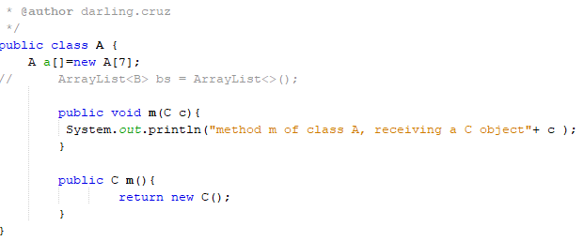

B ->

* + name 0.5/0.5
  + attribute 0.5/0.5

C ->

* + name 0.5/0.5
  + attributes 0.2/0.2
  + constructor 0/0.2
  + setters & getters 0/0.1

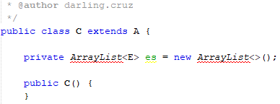

D ->

* + extends 0.4/0.4
  + constructor 0.4/0.4
  + setters & getters 0/0.2

E ->

* + name 0.8/0.8
  + attributes 0.2/0.2

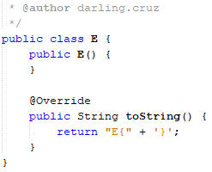

F ->

* + name 0.8 /0.8
  + to String 0.2/0.2

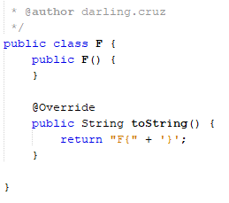

G ->

* + implements 0.5/0.5
  + method m() 0.5/0.5

H ->

* + interface and name 1,0/1.0
  + method m 1,0/1.0

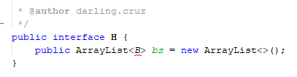

J ->

* + name 0.8/0.8
  + to String 0.2/0.2

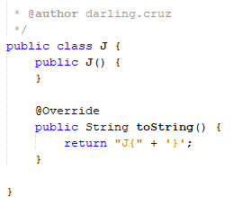

main ->

* + A a 0.4/0.4
  + ArrayList<B> bs 0.4/0.4
  + C[ ] cs = new C[3] 0/0.4
  + D[ ] ds = new D[4] 0/0.4
  + println() 0/0.4

Total 0.8

Total: 7.6/10 -> 11.4/15